**CS325 Homework 1**

**Screenshot for code compilation in Flip server :**

**Question 3** –

Implement merge sort and insertion sort to sort an array/vector of integers. You may implement the algorithms in C, C++, Java or Python, name the programs “mergesort” and “insertsort”. Your programs should be able to read inputs from a file called “data.txt” where the first value of each line is the number of integers that need to be sorted, followed by the integers. Example values for data.txt: 4 19 2 5 11 8 1 2 3 4 5 6 1 2 The output will be written to files called “merge.txt” and “insert.txt”.

**Merge Sort :**

File Name - MsortFile.java

Commands :

javac MsortFile.java

java MsortFile

File compiled & Run successfully :

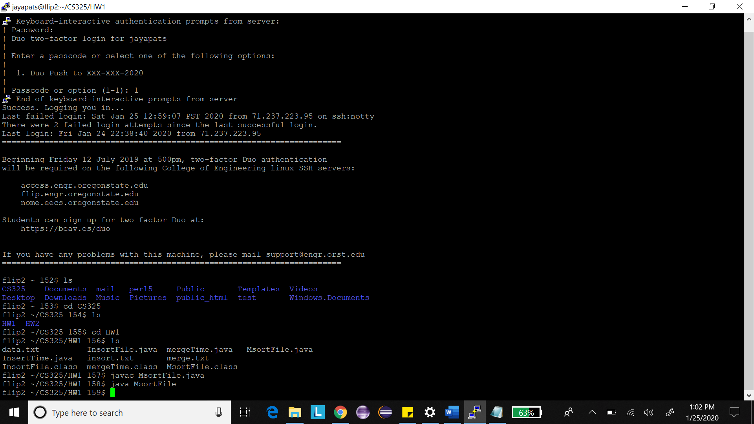

Output file merge.txt has been generated :

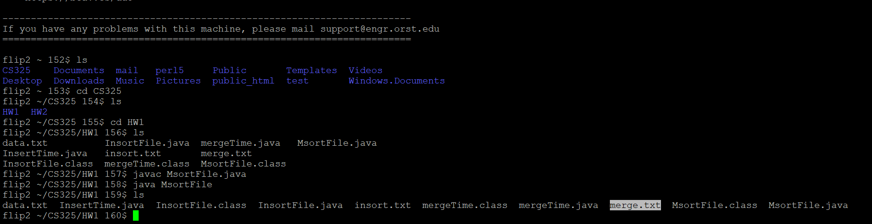

Sorted array in merge.txt file :

Command used to view file - view merge.txt

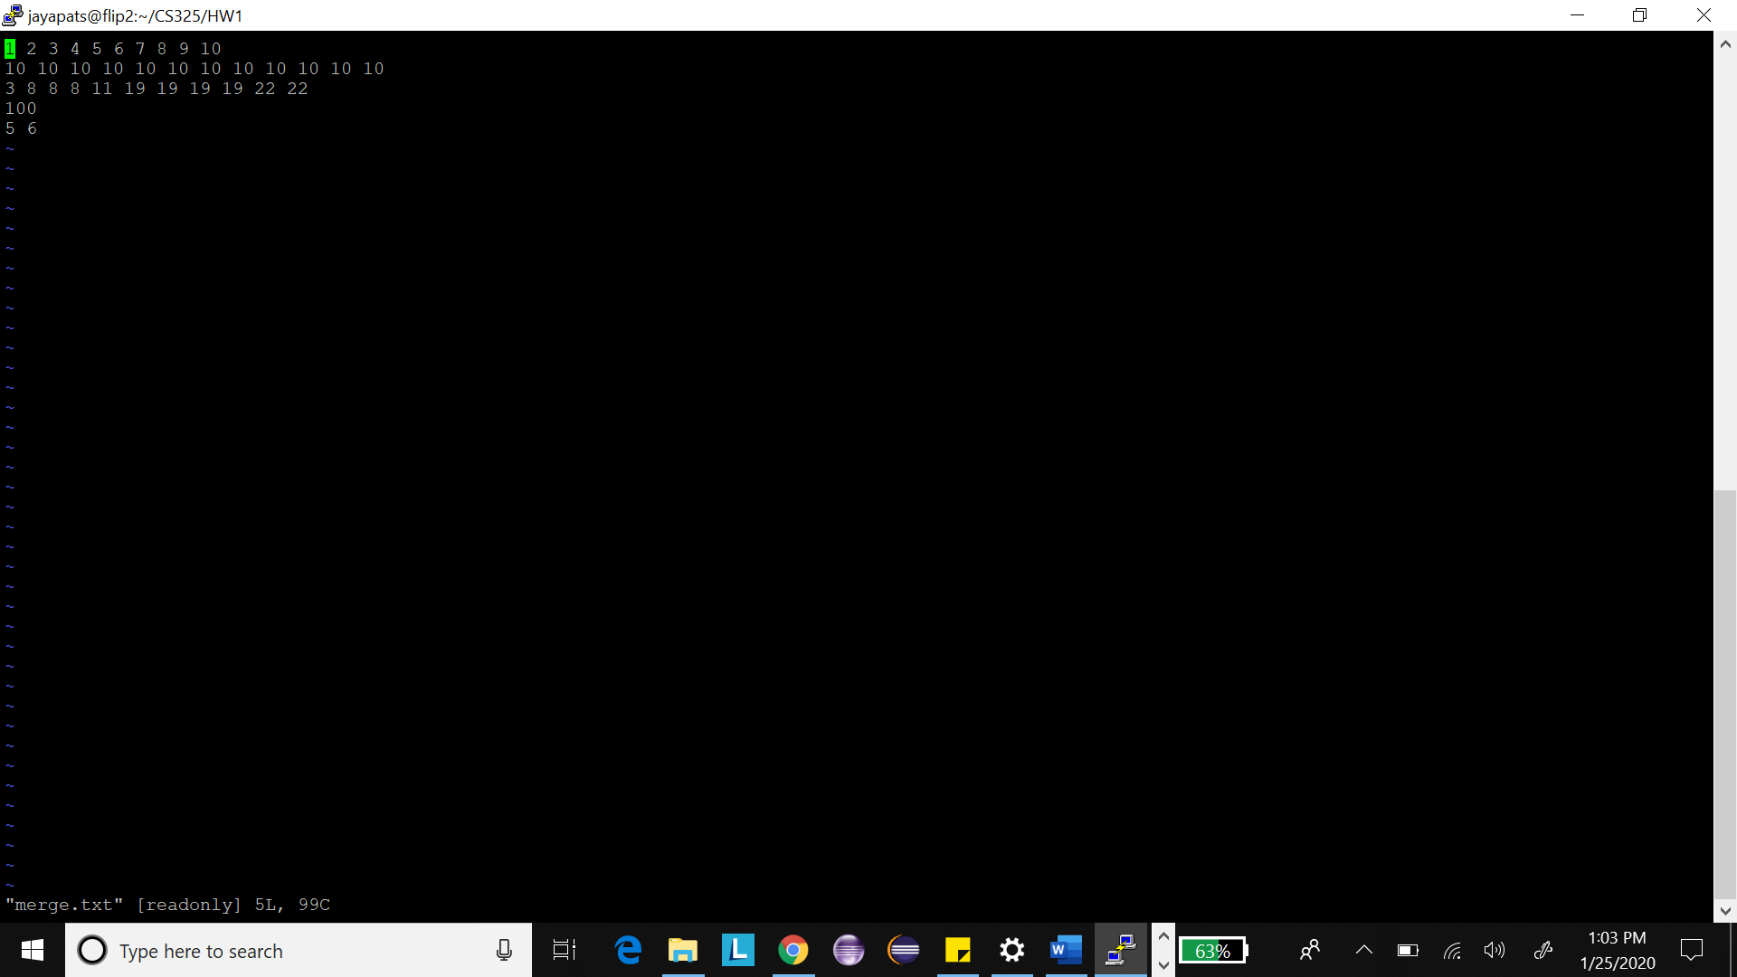

File Name - InsortFile.java

Commands :

javac InsortFile.java

java InsortFile

File compiled and run successfully :

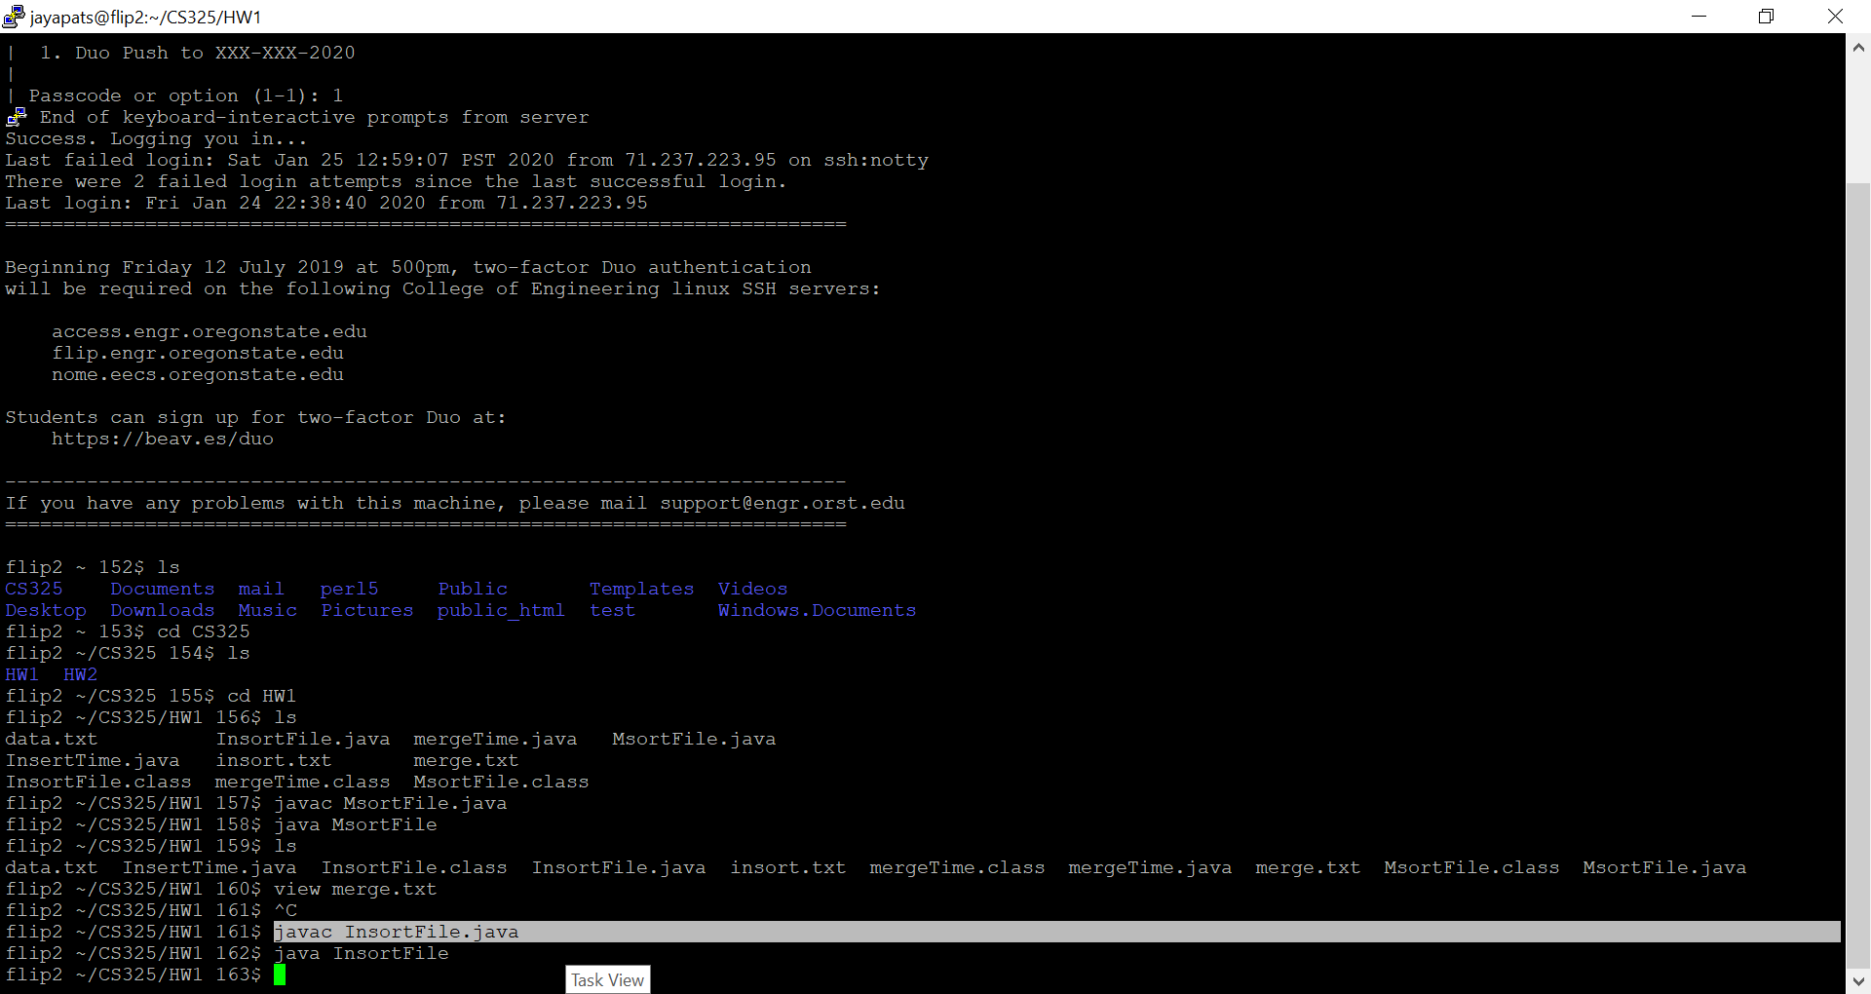

Output file – insort.txt has been generated successfully :

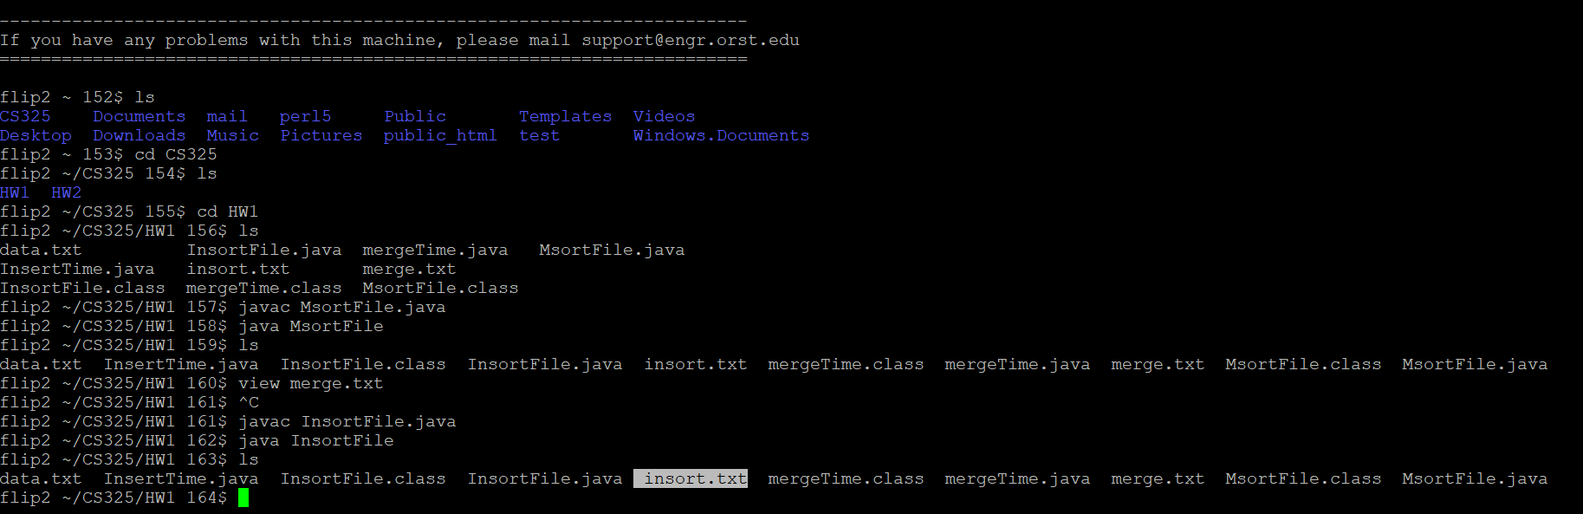

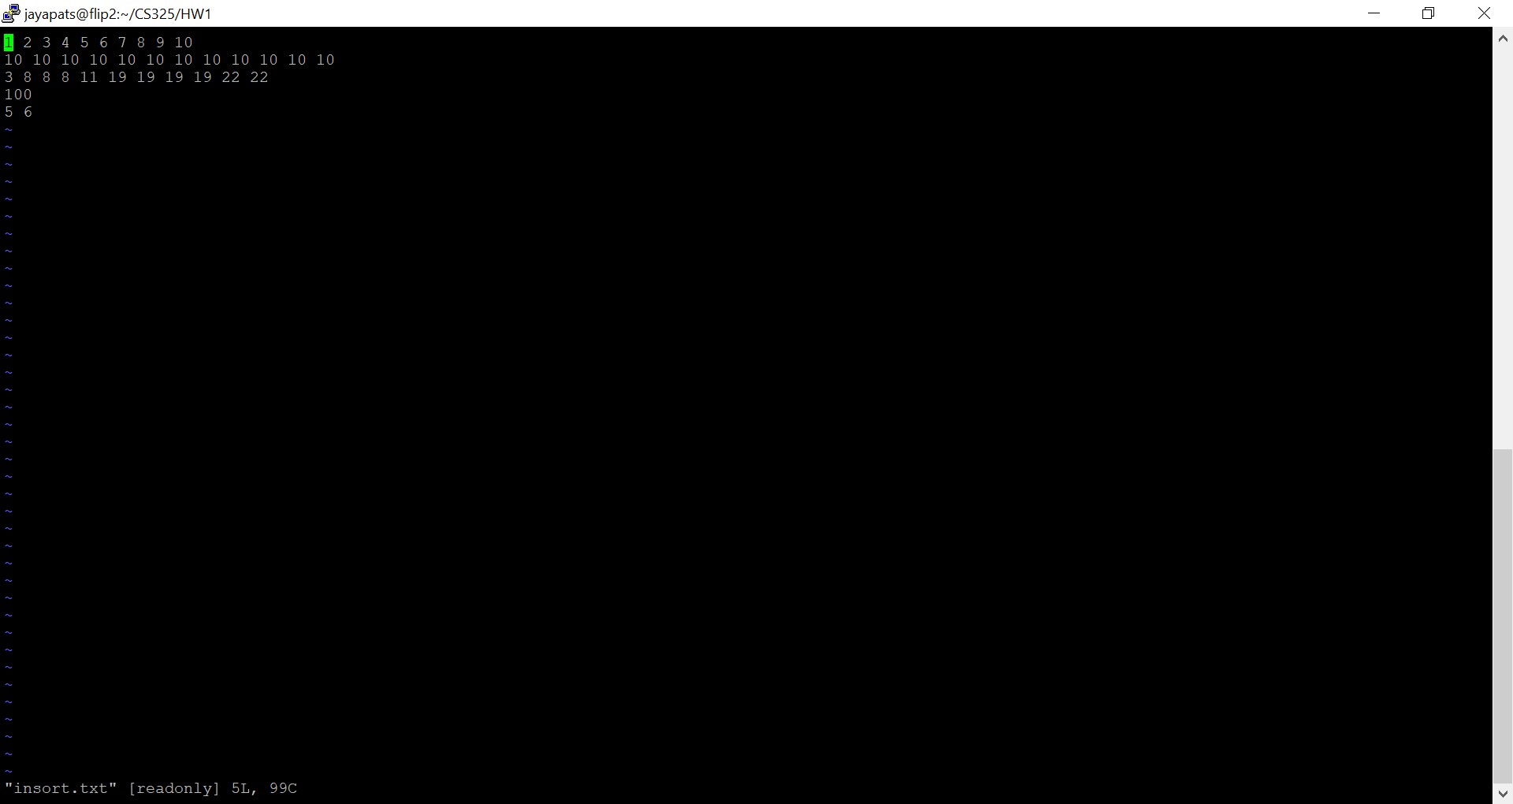

**Question 4 : Merge Sort vs Insertion Sort Running time analysis**

1. **Running time for Merge sort – by generating random number**

File Name - mergeTime.java

Commands :

javac mergeTime.java

java mergeTime

File compiled and run successfully :

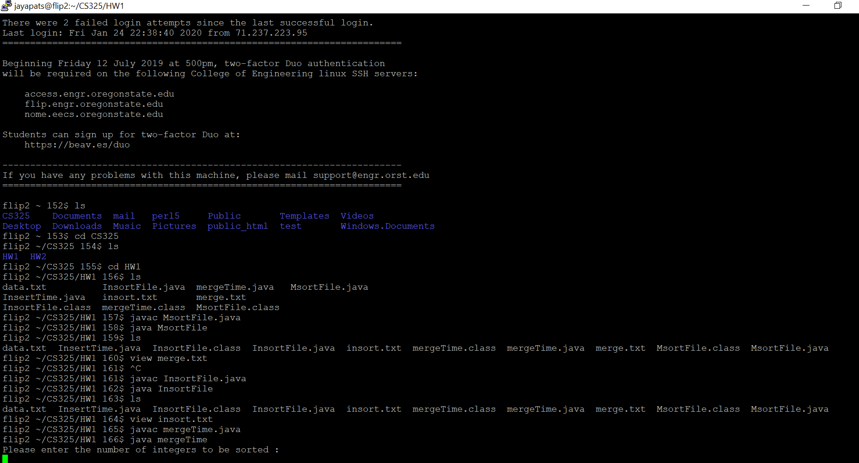

**It has been programmed by asking for the value of n and the value of ‘n’ and the Execution time is printed on the console :**

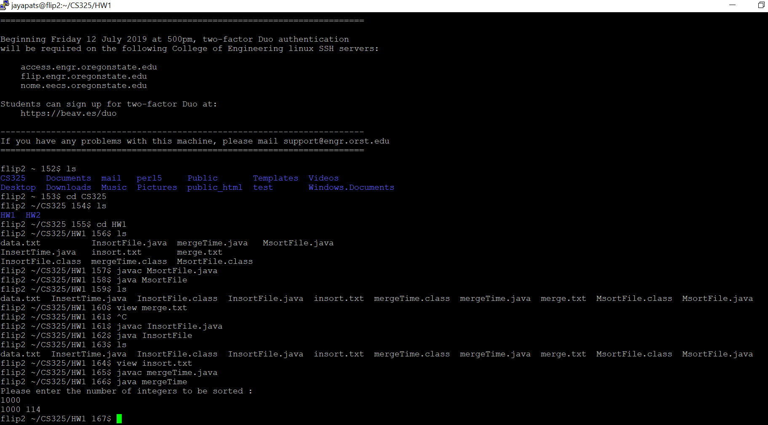

**2.Running time for Insertion sort – by generating random number**

File Name - mergeTime.java

Commands :

javac InsertTime.java

java InsertTime

**File Compiled and run successfully :**

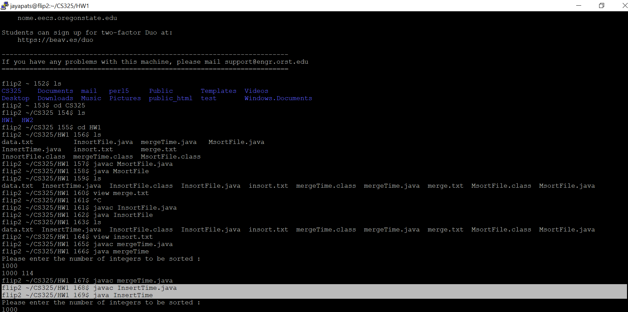

The value of n and the execution time is printed on the console(Highlighted one)

